Chapter 15, Solution 37.

(a) 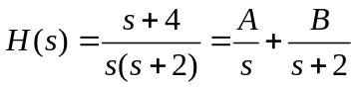

s+4 =A(s+2) + Bs
Equating coefficients,
s: 1 = A + B
constant: 4= 2 A A =2, B=1-A = -1

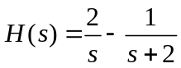
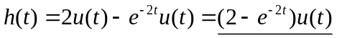

(b) 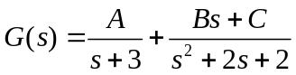

Equating coefficients,
s²: 1= B + A (1)
s: 4 = 3B + C + 2A (2)
Constant: 5 =3C + 2A (3)

Solving (1) to (3) gives
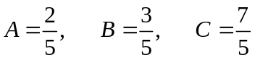
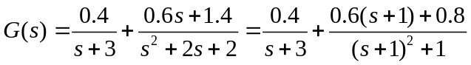
u(t)

(c) 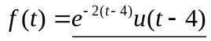

(d) 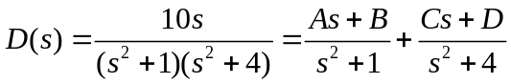

Equating coefficients,
s³ : 0 = A + C
s² : 0 = B + D
s: 10 = 4A + C
constant: 0 = 4B+D
Solving these leads to
A = -10/3, B = 0, C = -10/3, D = 0
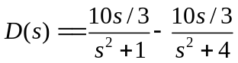
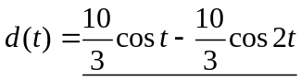u(t)

